

**TEAM 1_ONLINE SHOP**

**Software Requirement Specification**

– Hanoi, May 2022 –

Table of Contents

Project Report 3

1. Status Report 3

2. Team Involvements 3

I. Overview 3

1. Introduction 3

2. System Functions 5

II. Functional Requirements 7

1. Marketing 7

2. Public 16

3. Common 23

4. Admin 27

5. Customer 29

# Project Report

## 1. Status Report

|  |  |  |  |
| --- | --- | --- | --- |
| **#** | **Work Item** | **Status** | **Notes (Work Item in Details)** |
| 1 | Overall Description | Completed |  |
| 2 | Mock-Up screen | Completed |  |
| 3 | System Detailed Design | Completed |  |
| 4 | Object Specifications | Completed |  |
| 5 | Data & Database Design | Completed |  |

## 2. Team Involvements

|  |  |  |  |
| --- | --- | --- | --- |
| **#** | **Task** | **Member** | **Notes (Task Details, etc.)** |
| 1 | Overall Description | DucLM |  |
| 2 | Mock-Up screen | DucLM+HungNM+AnhNVA+ThachDP+HoangNV |  |
| 3 | System Detailed Design | DucLM+ThachDP |  |
| 4 | Object Specifications | HoangNV+VoNVA |  |
| 5 | Data & Database Design | HoangNV+HungNM |  |

# I. Overview

## 1. Introduction

The web application of the Online Procurement System (ShopOnline) for furniture stores aims to provide complete solutions to suppliers as well as customers through the single use of the internet. It allows customers to choose their favorite items as well as featured items and great promotions (Slider). See the positive as well as negative feedback of other customers (Feedback). Together share beauty secrets, know how to buy at the right time (Blogs).

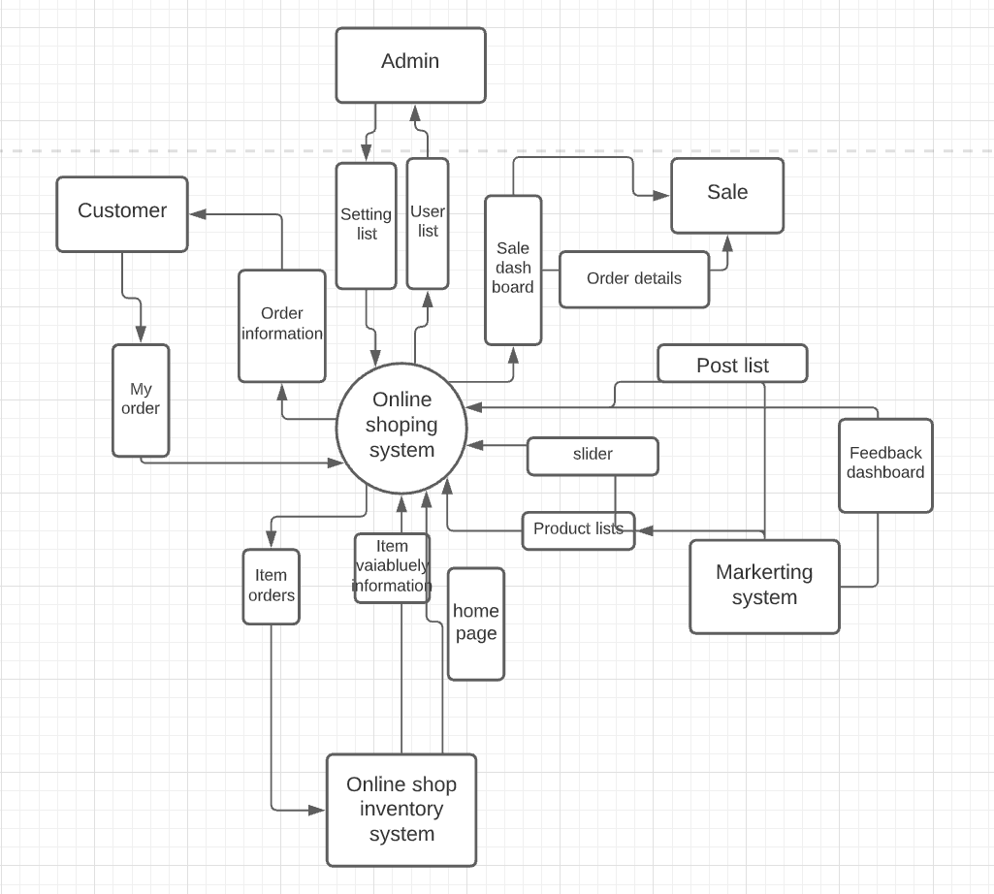

## 2. System Functions

*a. Screen Flow*

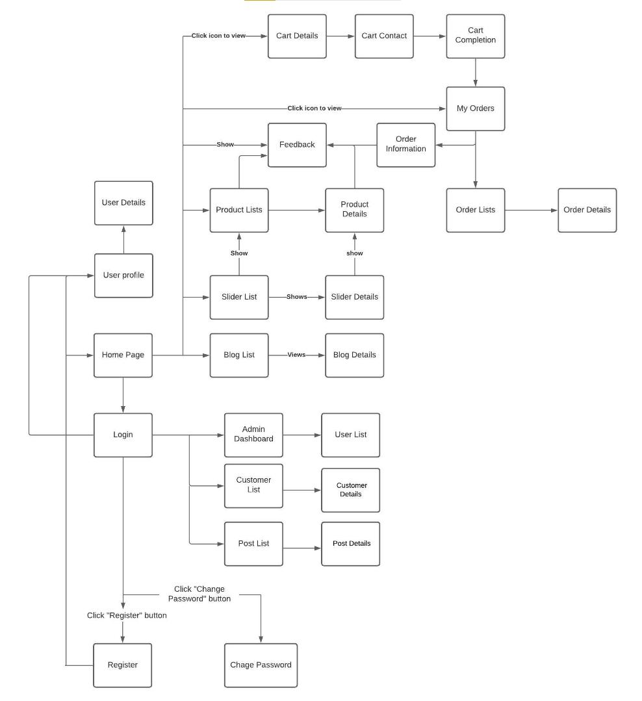

*b. User Authorization*

|  |  |  |  |
| --- | --- | --- | --- |
| **Screen/Functions** | **Admin** | **Customer** | **User** |
| Homepage | X | X | X |
| Blog | X | X | X |
| Blog Detail | X | X | X |
| Feedback |  |  | x |
| Feedback List | X | X |  |
| Feedback Detail |  | x |  |
| User Login | X | X | X |
| User Register |  | X | X |
| Slider list | X | X | X |
| Products List | X | X | X |
| Product Details | X | X | X |
| User Profile | X | X | X |
| Users List | X |  |  |
| User Details | X |  |  |
| Change Password | X | X | X |
| Customers List | X |  |  |
| Customer Details | X |  |  |
| Orders List | X |  |  |
| Posts List | X | X |  |
| Post Details | X | X |  |
| Order Information | X |  |  |
| Order Details | X |  |  |
| My Orders | X |  | X |
| Cart Contact | X |  | X |
| Cart Details | X |  | X |

# II. Functional Requirements

## 1. Marketing

*a. Feedbacks list*

*· Function trigger: /Feedbackcontroller*

*· Function description: Customer*

*· Screen layout:*

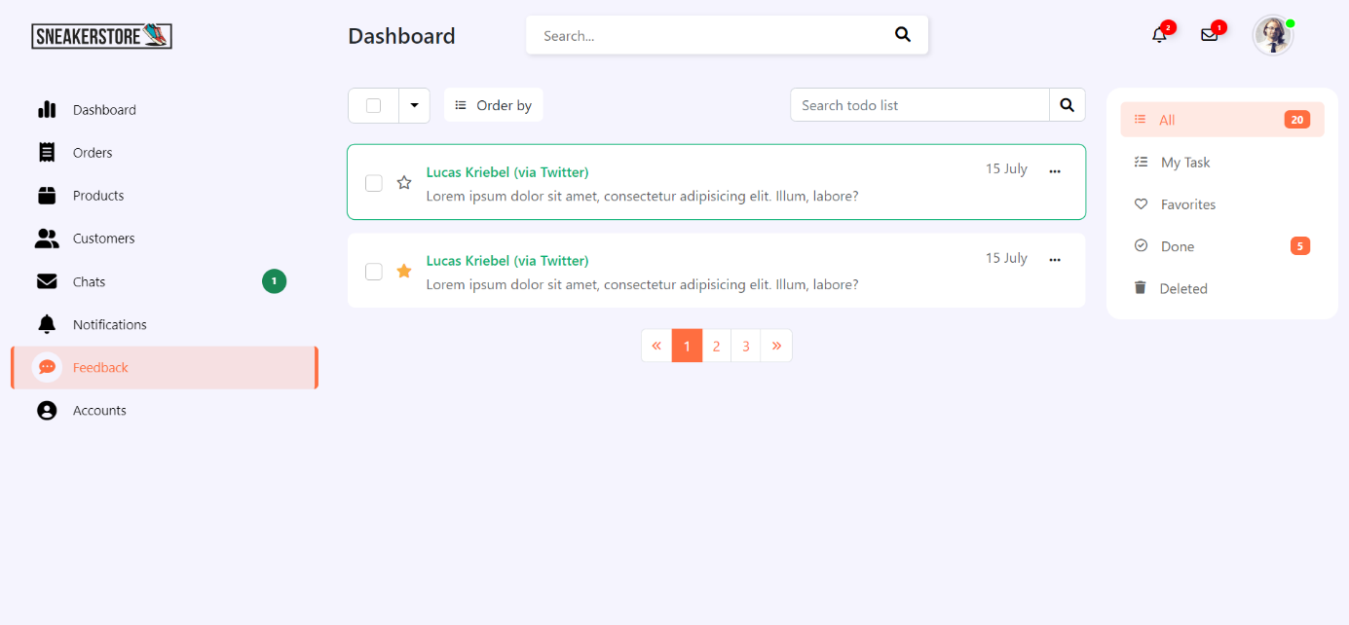

Function Details:

* Is a function for Customers to manage orders of customers who have purchased shoes. In "Action" there are two states "Pending" and "Resolve" so that the customer knows that he has processed this order yet.
* Have pagination, search to best support customers, and watch customer feedback

*b. Feedback Details*

*· Function trigger: /FeedBackDetail?*

*· Function description: Customer*

*· Screen layout:*

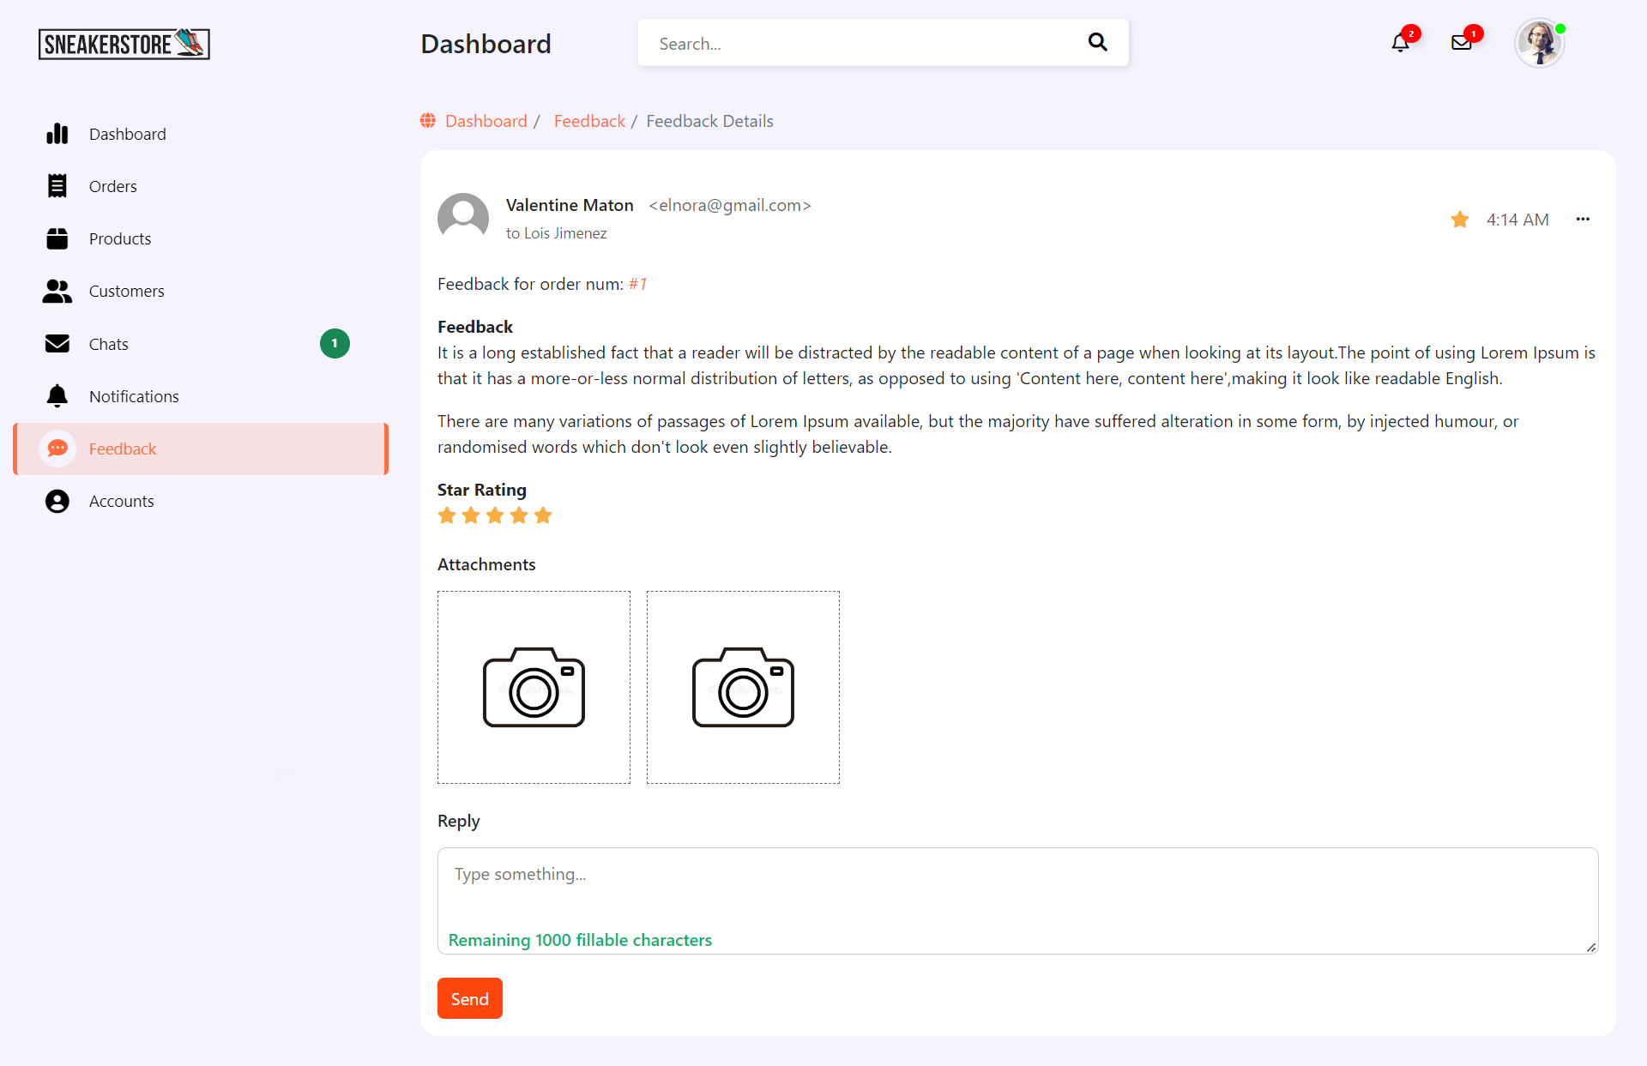

Function Details:

* Display customer information, number of stars and customer feedback. There is a 'note' section for customers to note shortcomings or improvements from customer feedback

*c. Customer List*

Function trigger : HomeController/ListCustomer

Screen layout : 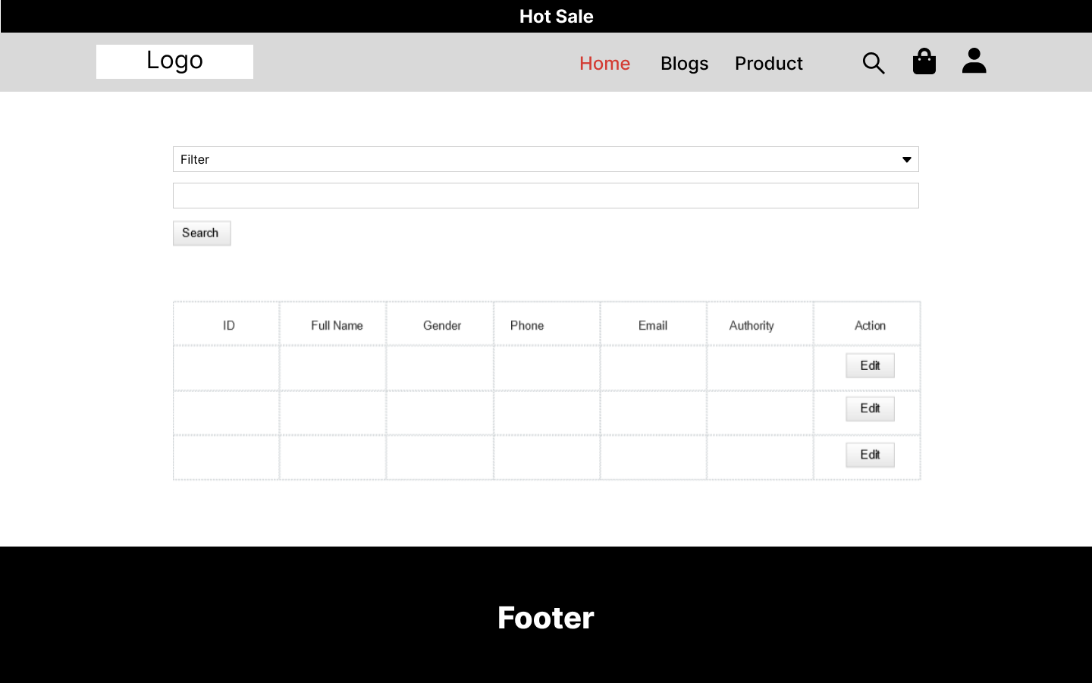

Function detail :

* Show the list of customers / contacts paginatedly (include contacts' id, full name, gender, email, mobile, status):
* Sortable by full name, email, mobile, status
* From each customer, the user can choose to add new, view or edit it

*d. Post List*

Function trigger: Homepage/Post

Function description: User, Admin

Screen layout:

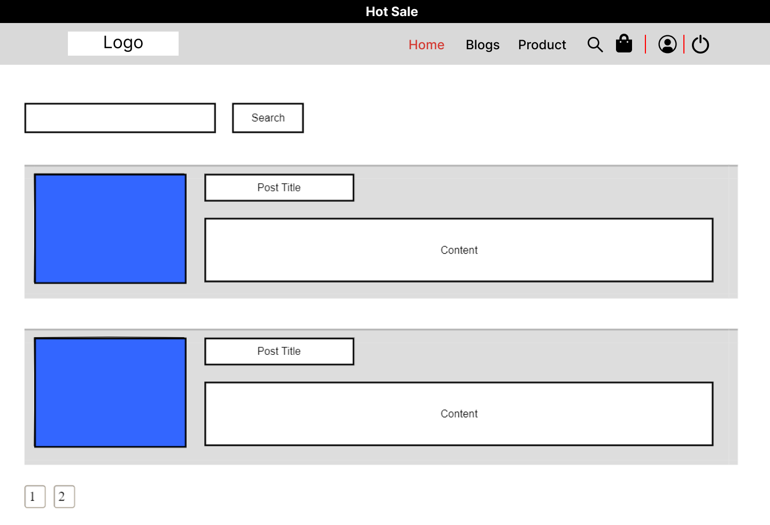

Function detail:

- Show the paginated list of posts contain id thumbnail, title

- User can filter the post or sort by category, author, status

- User can choose to add, show, edit or delete post

*e. Post Detail*

Function trigger: Homepage/Cart.

Function description: User, Admin

Screen layout:

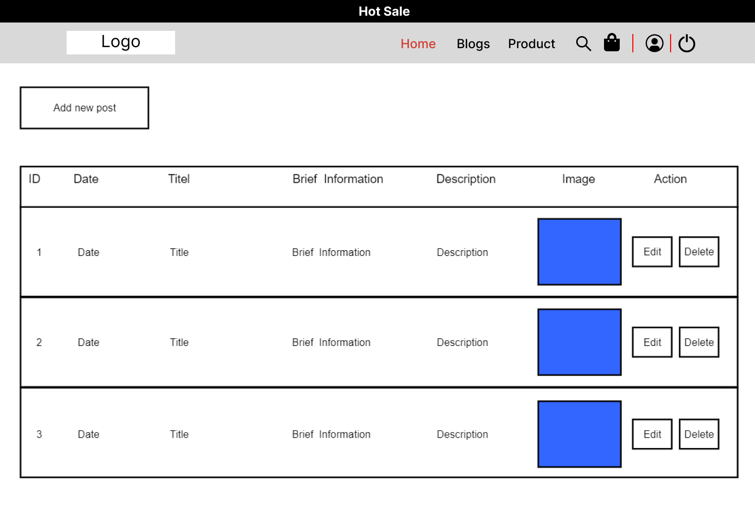

Function detail:

- Show detailed post information include thumbnail, category, brief information, author, feature and status

f. Sliders List

Function trigger : HomeController/listslide

Function description: Admin

Screen layout :

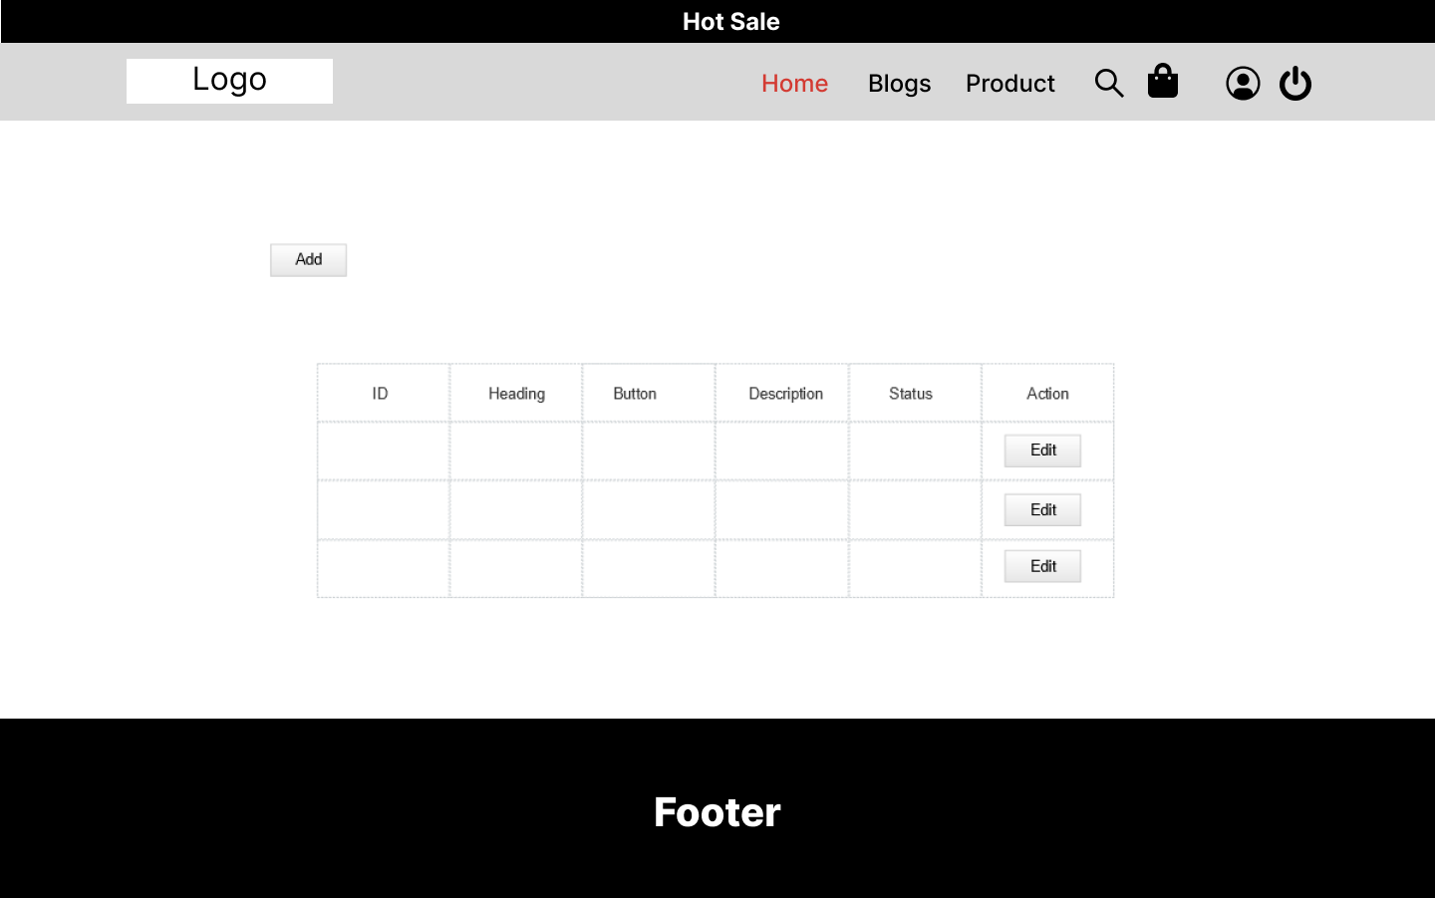

Function detail : 'This is a pop-up screen which allows the user to change his/her password by inputting his current password as well as new password (twice)

g. Products List

Function trigger : HomeController/listproduct

Function description: Admin

Screen layout :

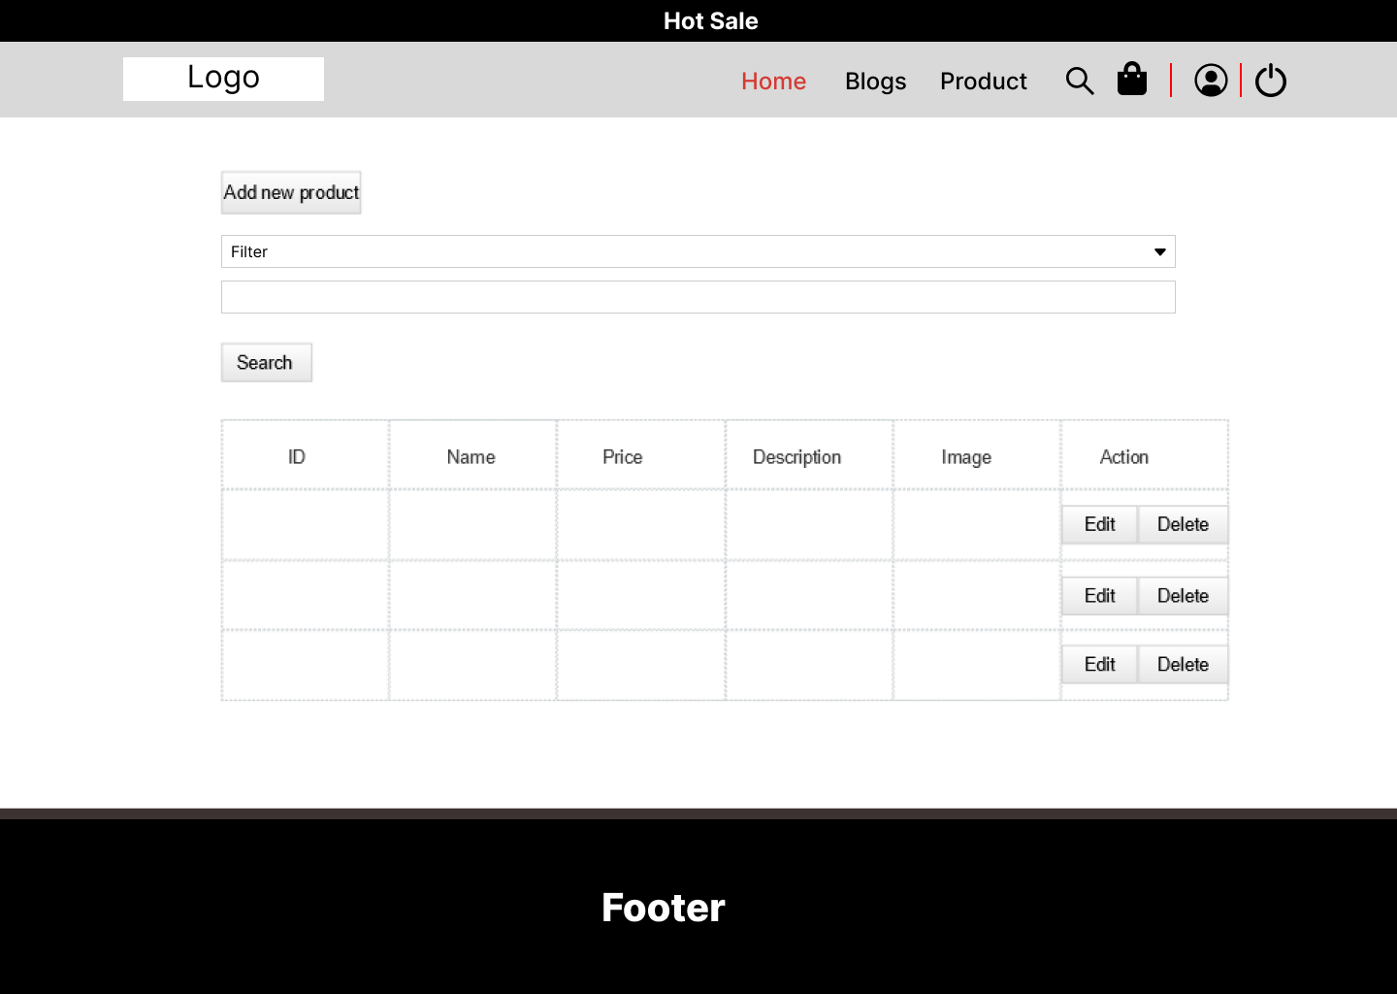

Function detail :

* This is a pop-up screen which allows the user to edit his/her profile information, including the registered ones & the avatar image. Please note that s/he is not allowed to change the emailDetails page

h. Orders List

Function trigger : HomeController/orderlist

Function description: Admin

Screen layout :

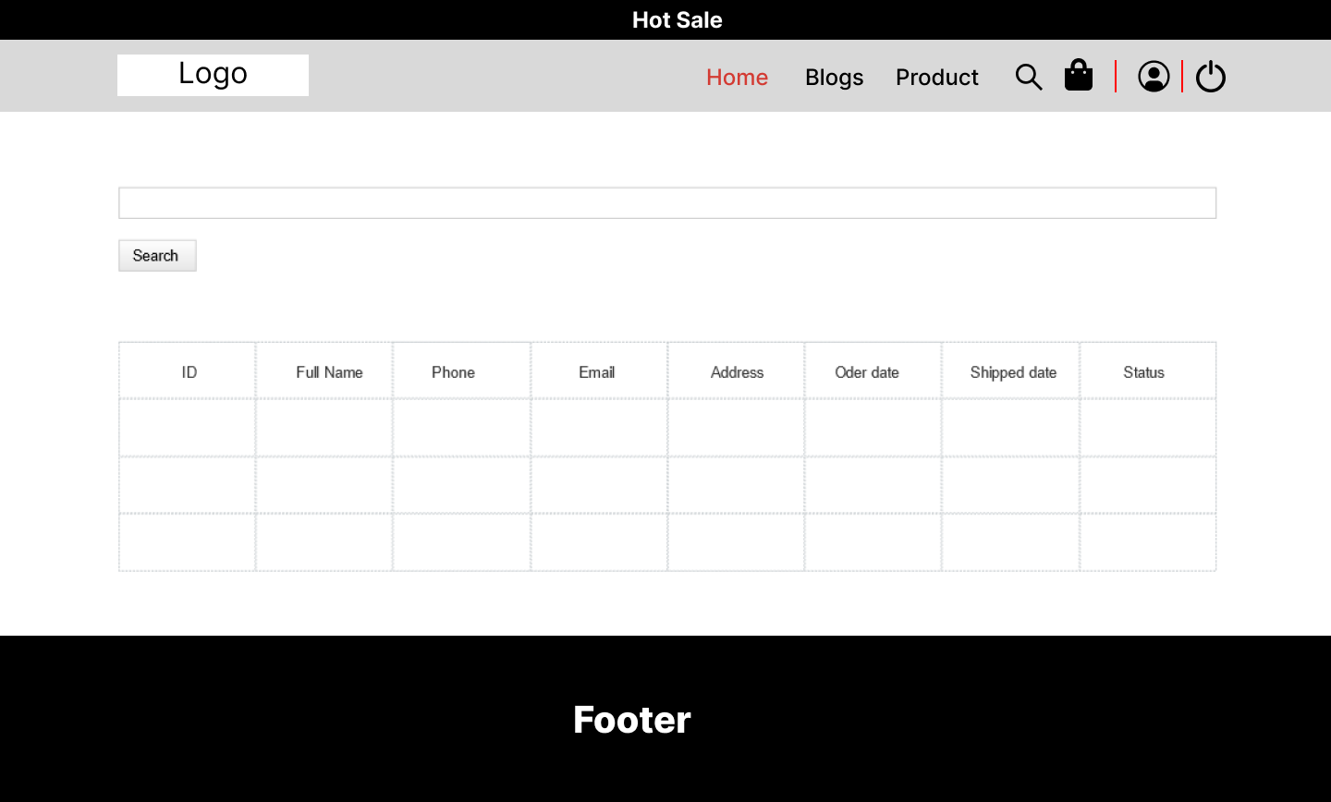

Function detail :

* Show the list of orders paginatedly
* Each order include below information: id, ordered date, customer name, product (first product name & number of other products if any), total cost, status;
* Allow the user to search the orders by order id, customer name
* On clicking the link under the order id, user would be redirected to the Order Details page

i. Customer Detail

Function trigger : HomeController/ListCustomer/ProfileUserController

Function description: Admin

Screen layout :

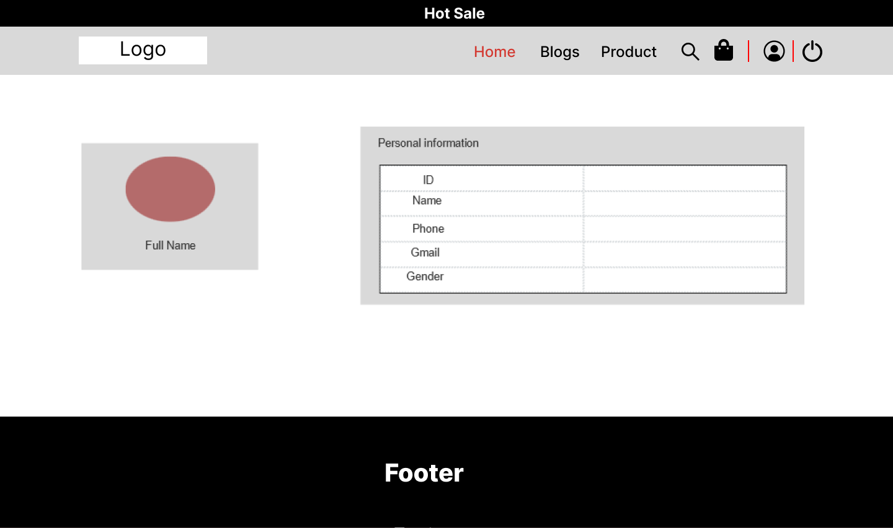

Function detail :

* Show detailed customer/contact information (full name, gender, email, mobile, address, status), from that allow the user to input, view or edit them (excep for the status which is generated automatically - contact, potential or customer)

k. Product detail

Function trigger : HomeController/listProduct/DetailProductcontroller

Function description: Admin

Screen layout :

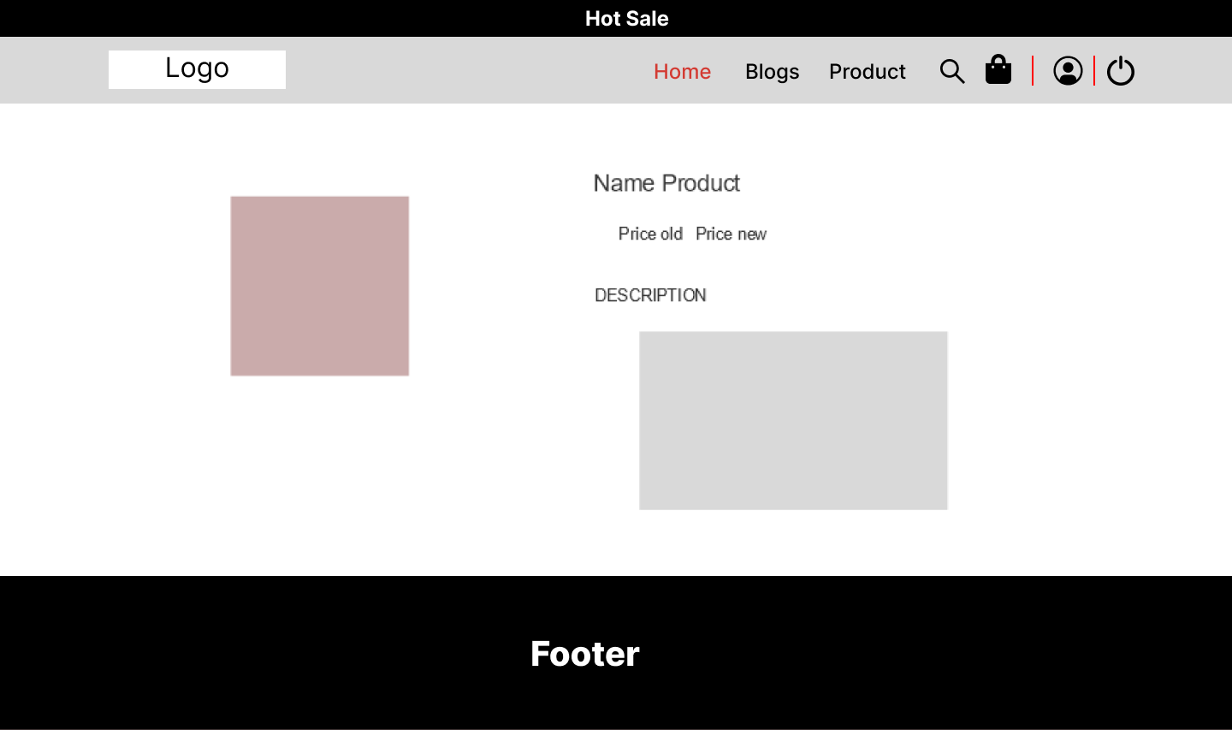

Function detail :

* Show detailed product information (thumbnail, category, title, brief information, attached images, description, quantity, list price, sale price)

## 2. Public

*a. Home Page*

*· Function trigger: /HomeController*

*· Function description: Admin, Customer, User*

*· Screen layout:*

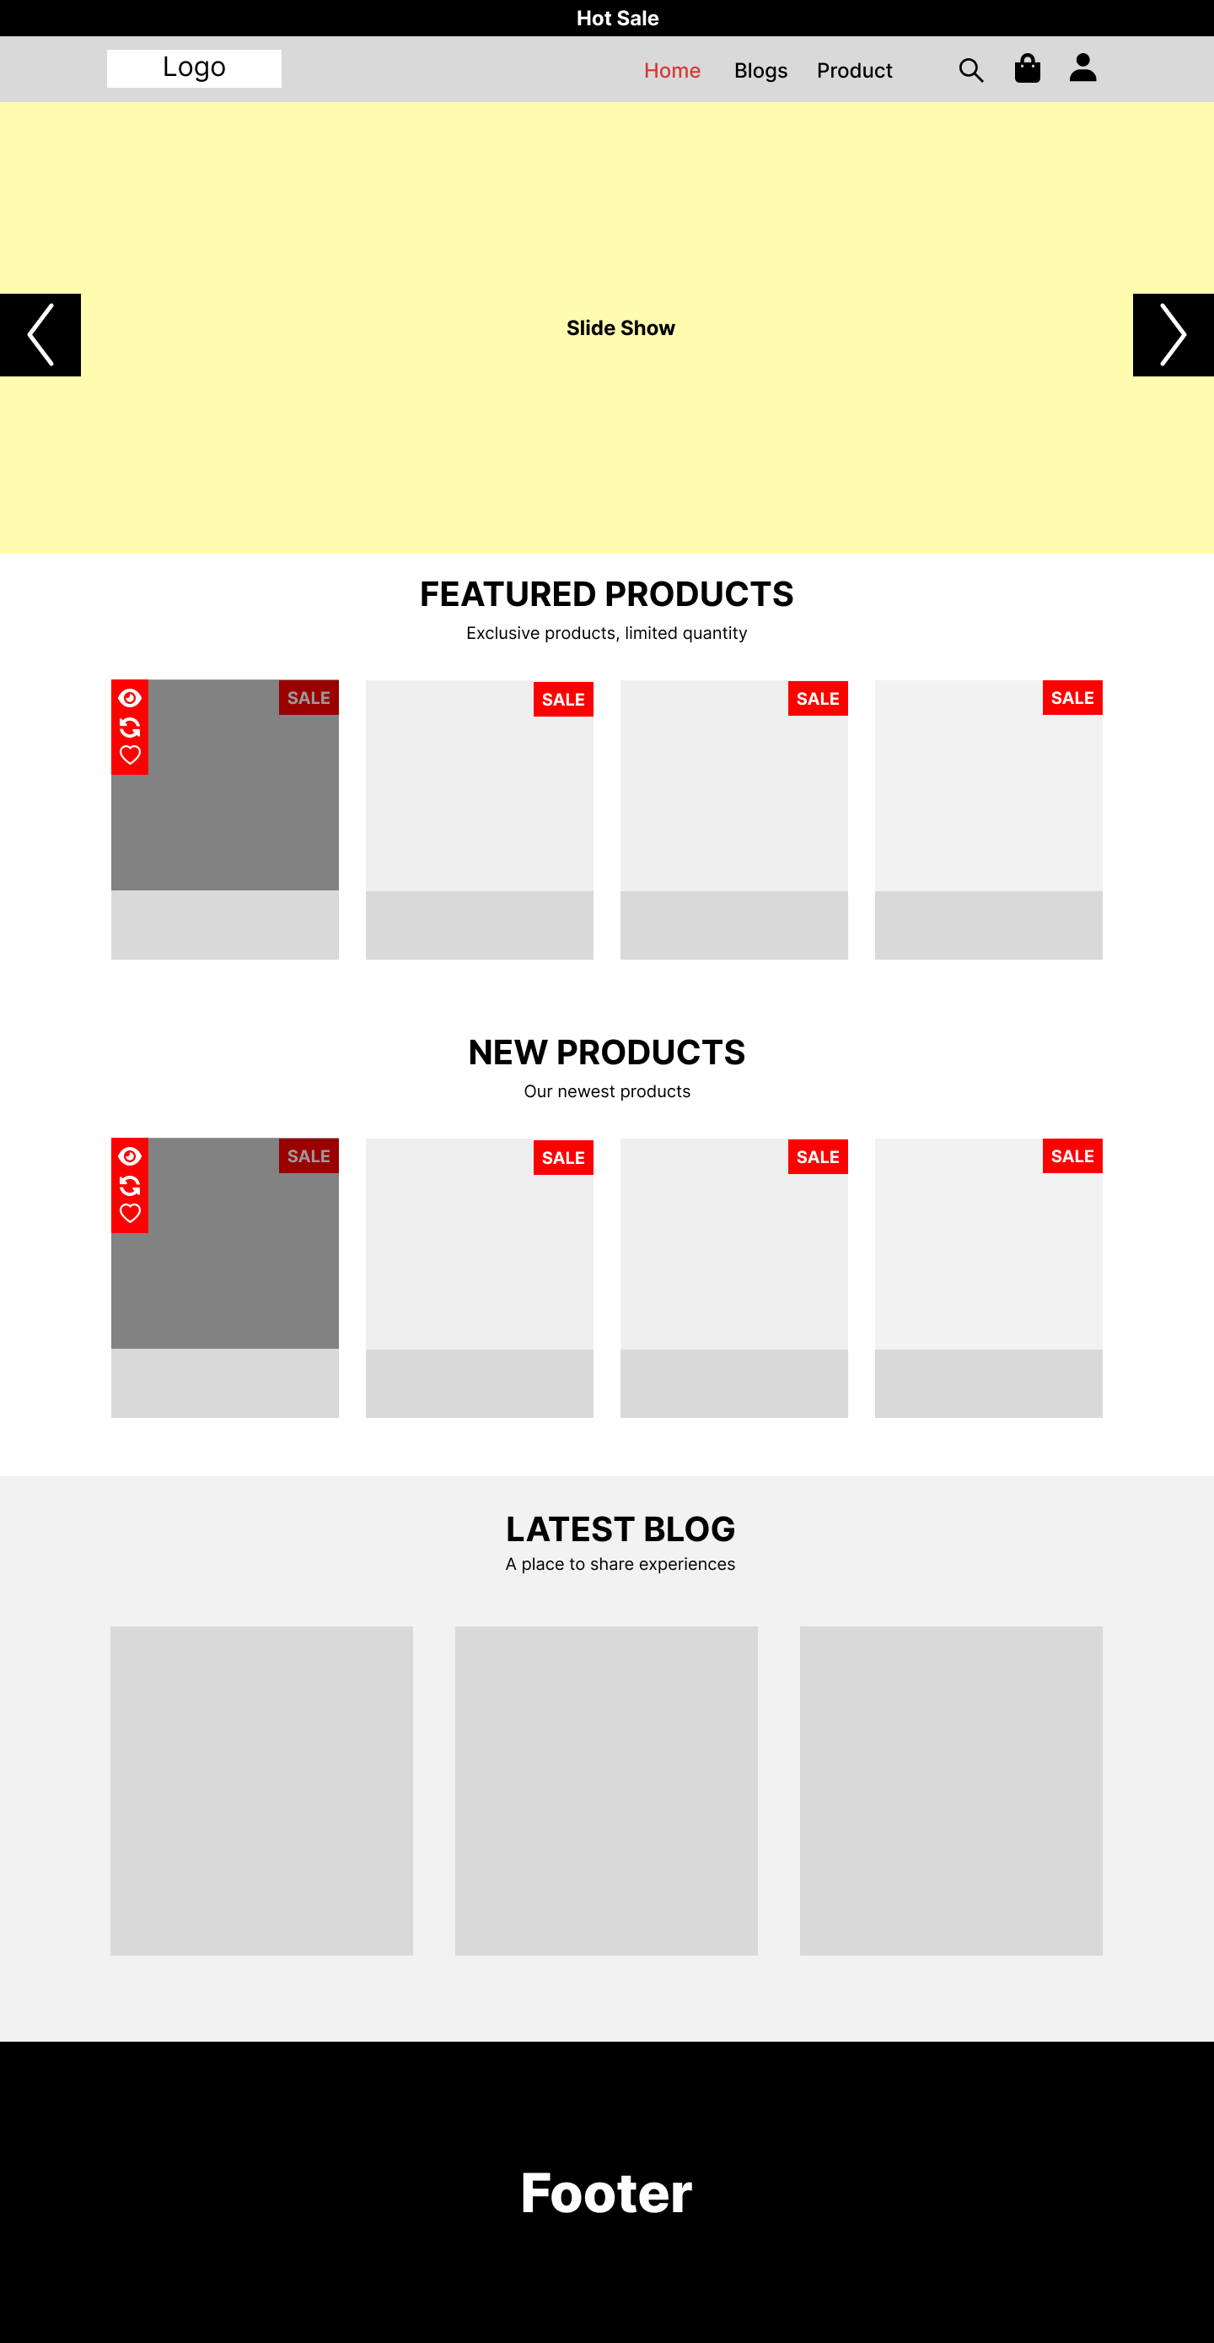

Function detail :

* The page that the user will see before and after logging in. Show featured products, new products, valuable experiences.
* From this page users can access the Blog, Product page

*b. Feedback*

*· Function trigger: /Feedback?pid=?*

*· Function description: User*

*· Screen layout:*

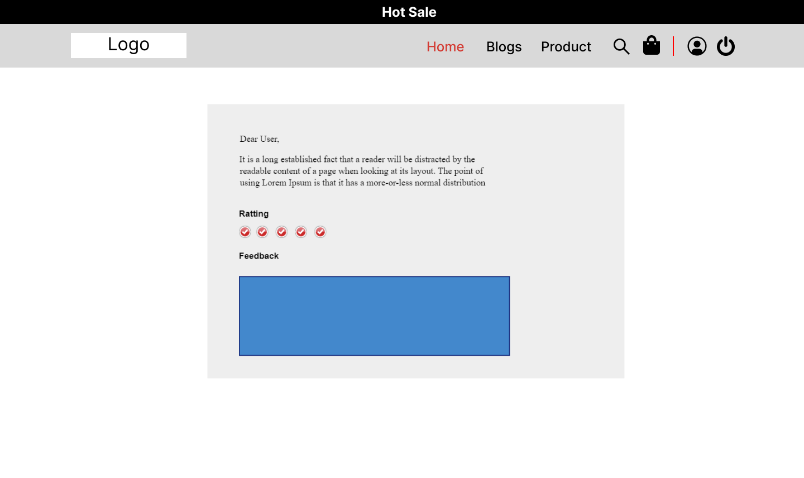

Function detail :

* After making a purchase, the user will receive a feedback email about the product
* Click on the link displayed in Mail. Customers will be redirected to a new website to reflect on the product including content and stars

*c. Blogs List*

*· Function trigger: /blog*

*· Function description: User, Customer, Admin*

*· Screen layout:*

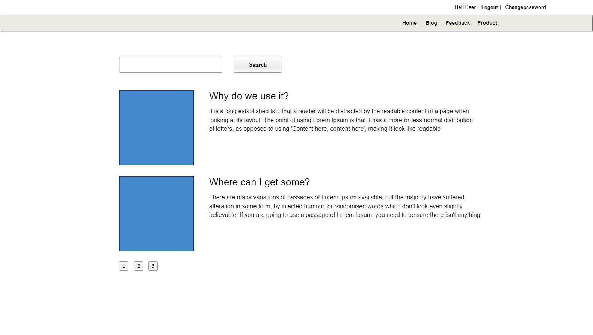

Function detail :

* Experience sharing page written by customer or admin.
* There is a search function so that users can more easily find interesting readings

*d. Blog detail*

*· Function trigger: /blogdetail?id=?*

*· Function description: User, Customer, Admin*

*· Screen layout:*

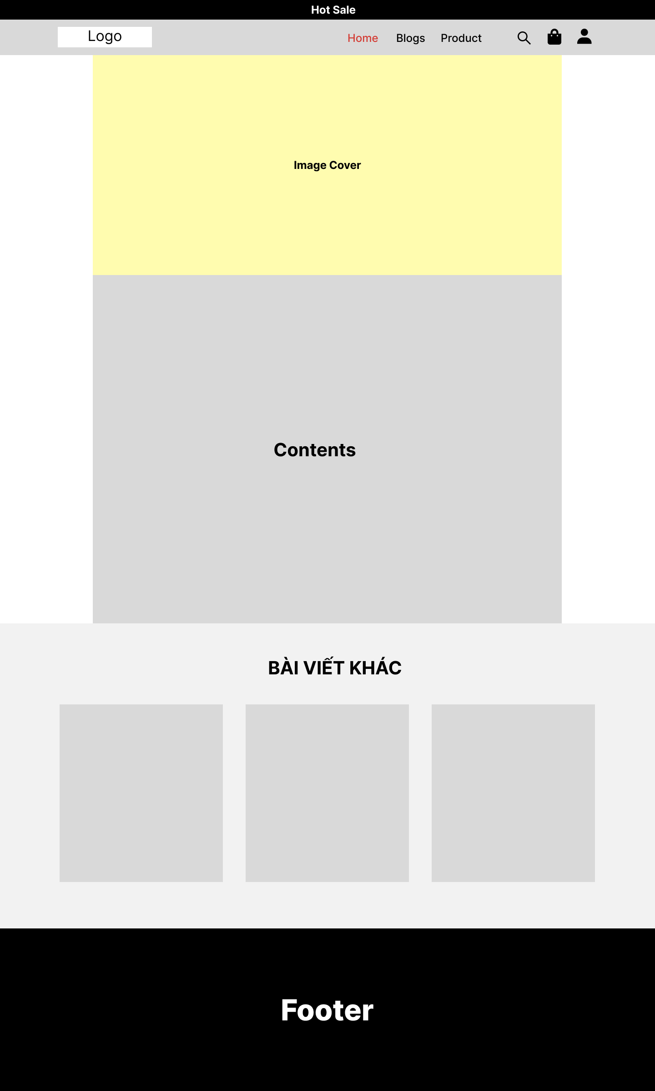

Function detail :

* Show article details including content title
* Besides, users can see how related posts are on the right side of searching other articles

*e. Cart Details*

Function trigger: Homepage/Cart.

Function description: User, Admin

Screen layout:

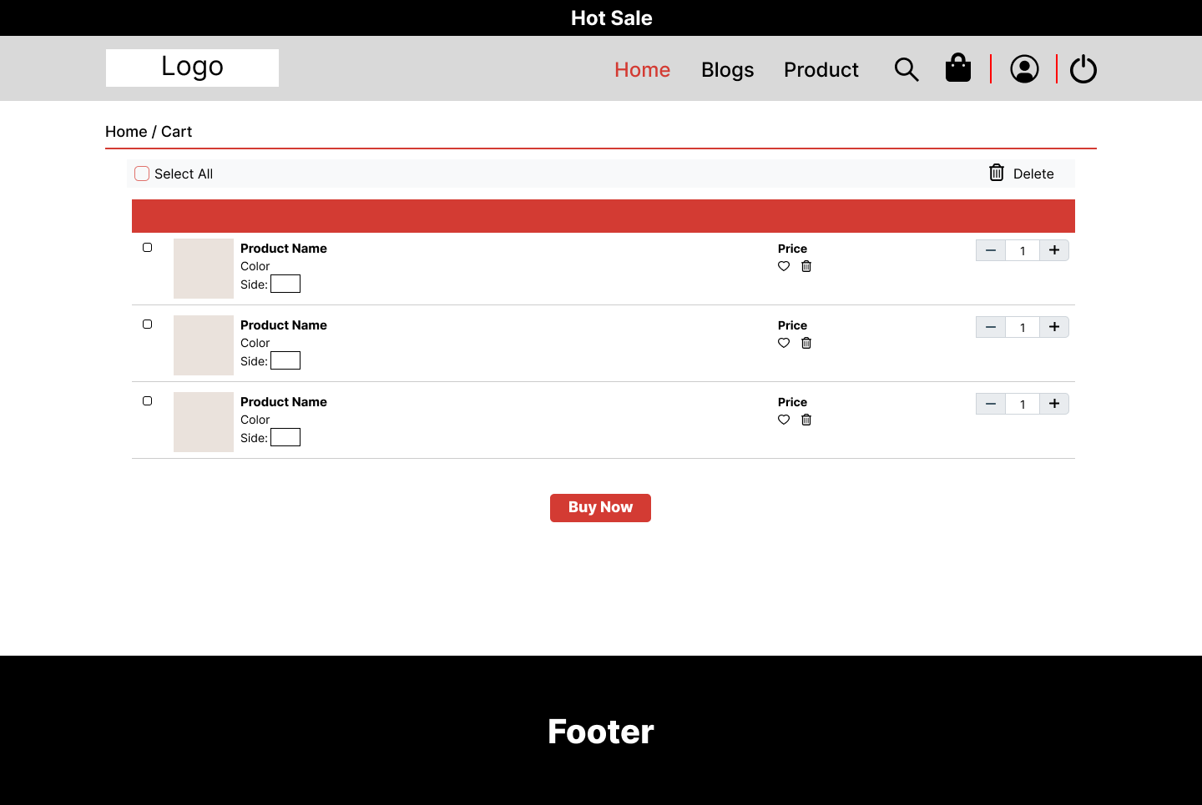

Function detail:

- Show the cart details with list of the chosen products display information such as title, price, quantity and total cost

- User can perform some action: change quantity, remove chosen product, buy more product or check out

*g. Cart Contact*

Function trigger: Homepage/Cart/Cart detail

Function description: User, Admin

Screen layout:

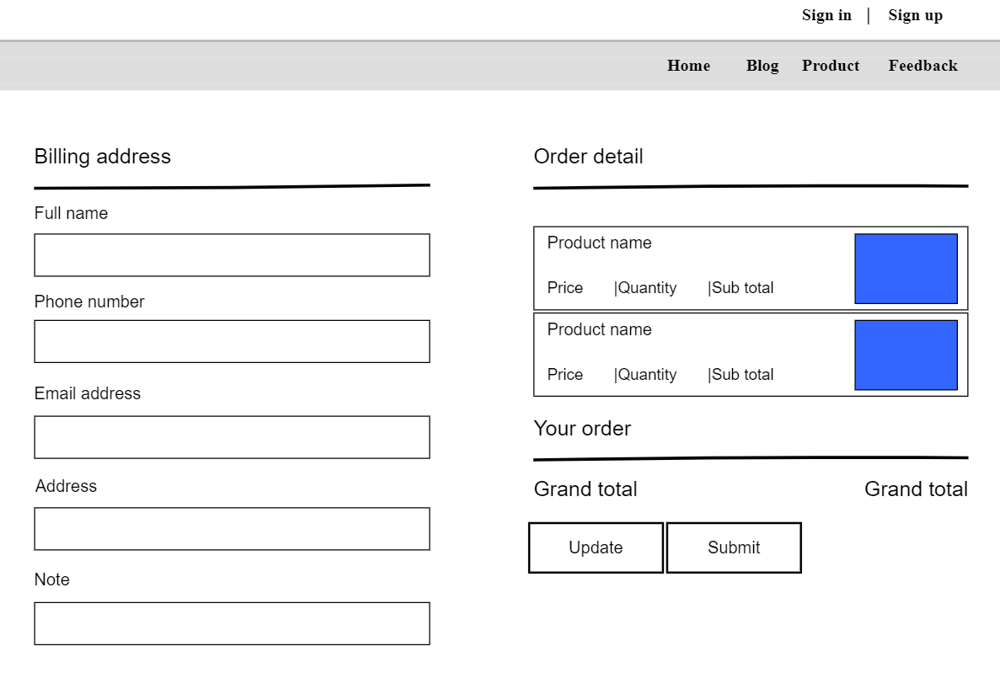

Function detail:

- Show the list of the chosen products display information such as title, price, quantity and total cost

- Show the slider with search box, product category, latest product

- User can input their receiver information including their name, phone, email, address

*h. Product Details*

Function trigger: Homepage/click on the product you want to look at.

Function description: Customer, User, Admin

Screen layout:

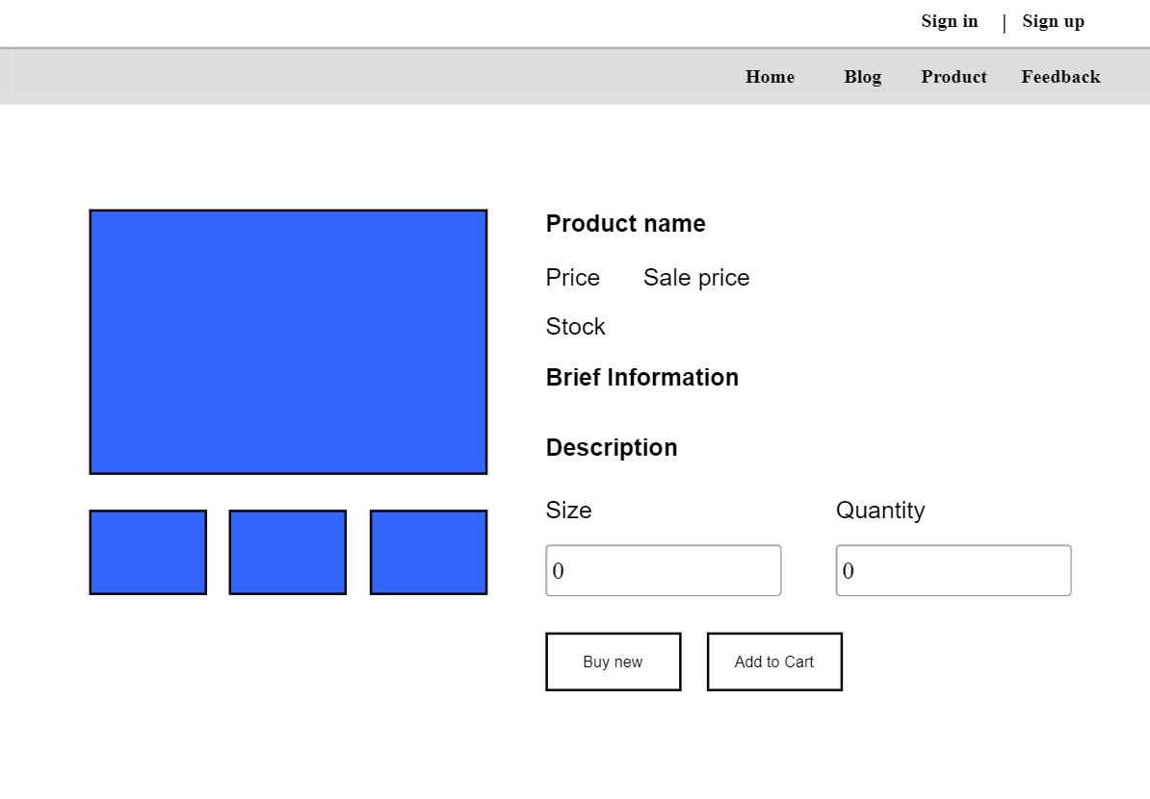

Function detail:

- Show product details including title, images, price brief information and description

- Show sider with other information such as search box, product categories, the latest products, and static contacts/links

## 3. Common

*a. User Login*

*· Function trigger: /login*

*· Function description: User, Customer, Admin*

*· Screen layout:*

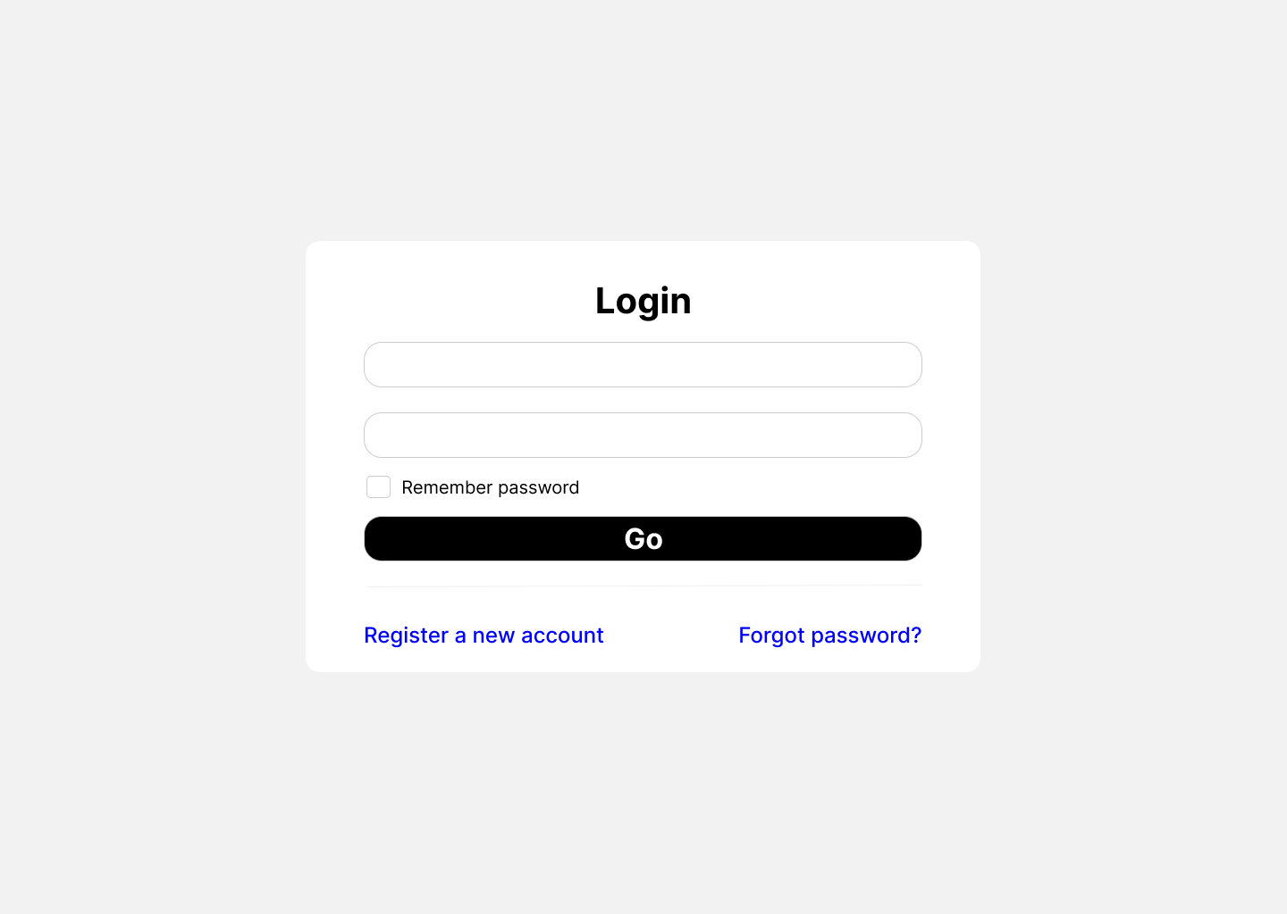

Function detail :

* As a user, the function can make purchases after logging in.
* After checking correct Gmail and password user can login to website and tasks in it

*b. Register*

*· Function trigger: /register*

*· Function description: User*

*· Screen layout:*

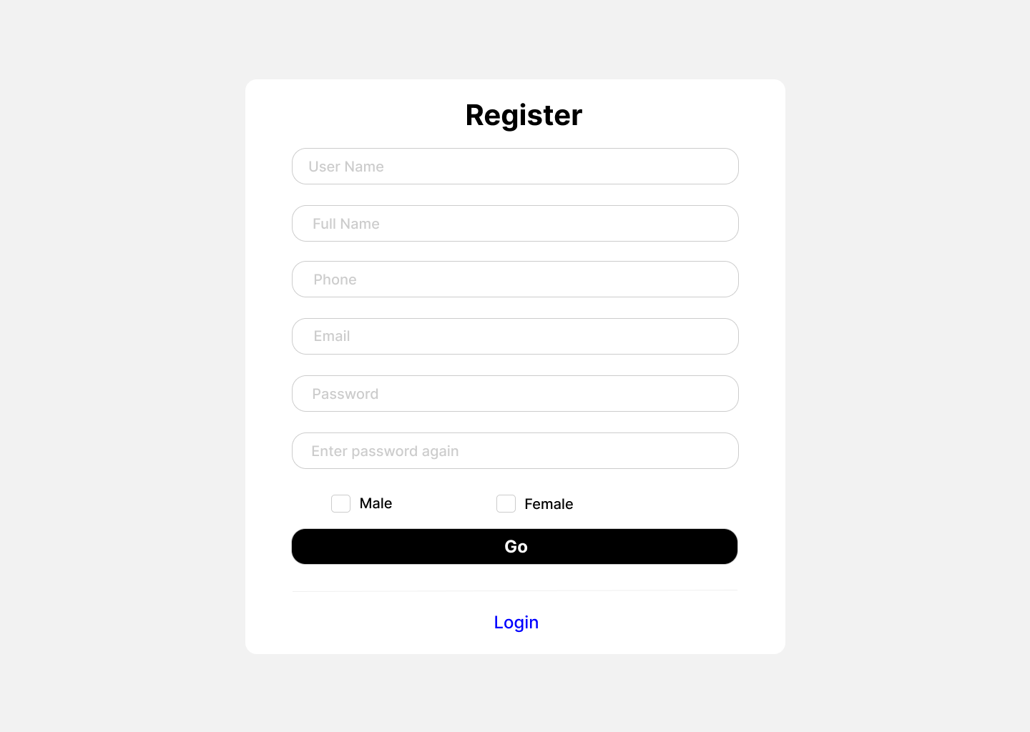

Function detail :

* For users who do not have an account to log in.
* Users will fill in the correct information that the website requires. Especially if the username is the same or the email is already registered on this website, you must use a new one

*c. User profile*

Function trigger : HomeController/profile.jsp

Function description: User

Screen layout :

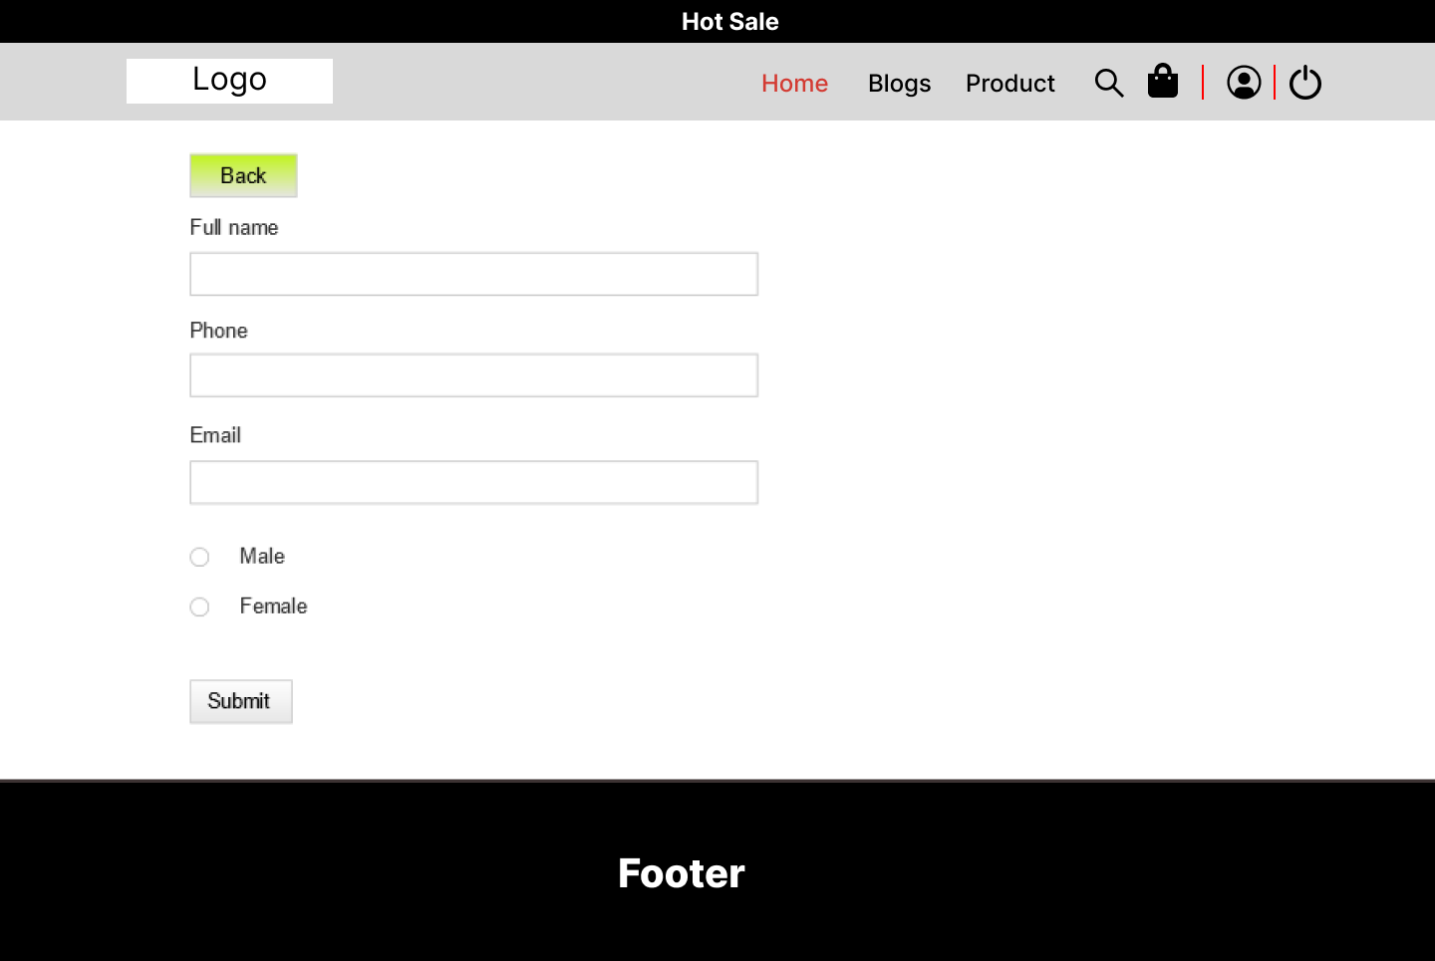

Function detail :

* Show the paginated list of products (include products' id, thumbnail, title, category, list price, sale price, featured, and status information):
* Sortable by list price, sale price
* The page also have the button/link that allows the user to add new product , edit , search .

*d. Change password*

Function trigger : HomeController/changepassword.jsp

Function description: User

Screen layout :

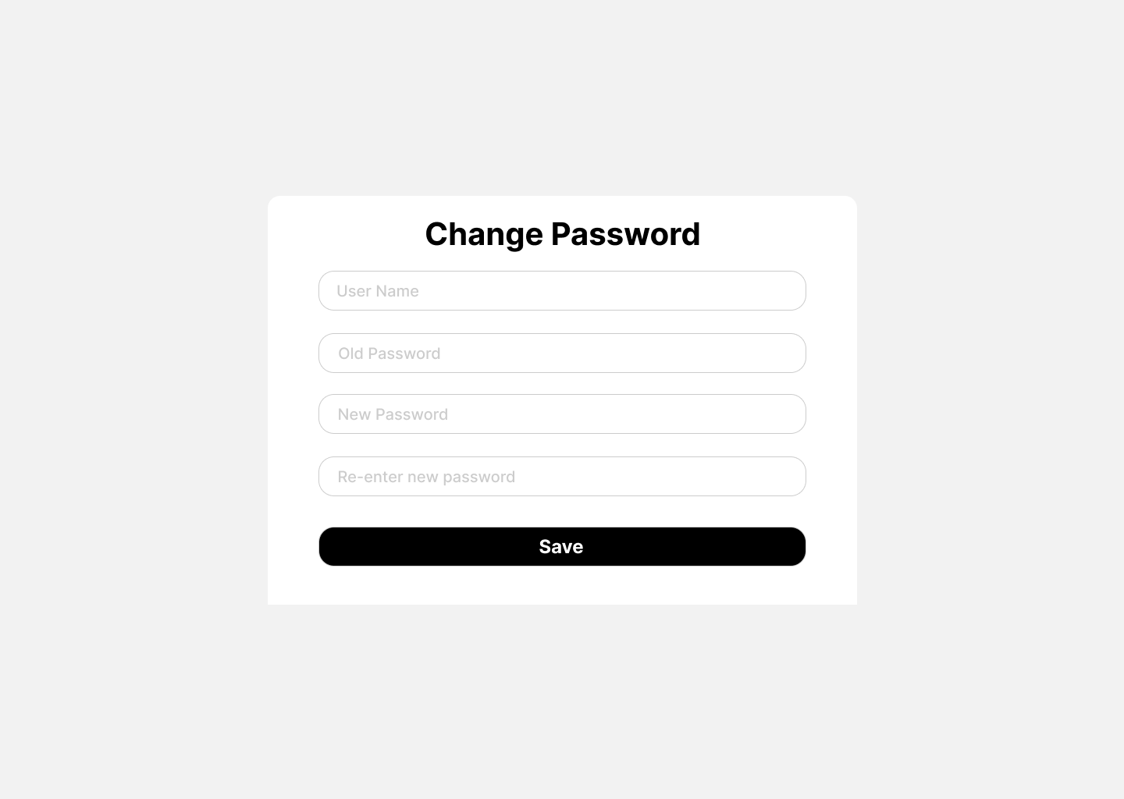

Function detail :

* Show a paginated list of sliders (including id, title, image, backlink, slider's status)
* Admin can add and edit it
* For each slider, user can choose to hide, show
* *b. Order Information*
* Function trigger: Homepage/My order/Order Information
* Function description: User
* Screen layout:
* 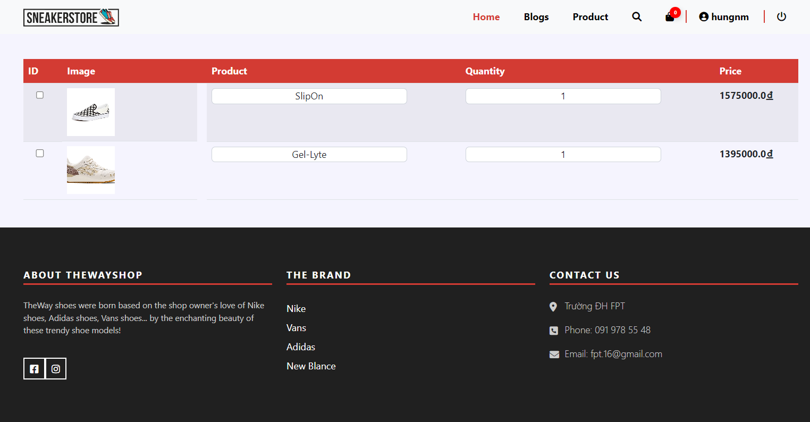
* Function detail:
* Display details of order information, quantity, product name, price, and order codes that customers have ordered.
* *c. Notification*
* Function trigger: Homepage/My order/Notification
* Function description: User
* Screen layout:
* 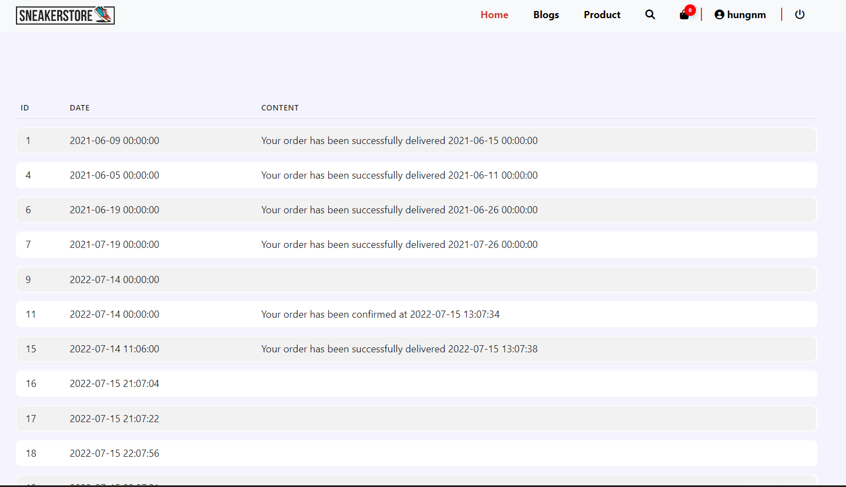
* Function detail:

The message is displayed with the date and status of the customer's order being confirmed or delivered successfully

* *D. Cart Completion*
* Function trigger: Homepage/CartController/CartContact/CarCompletion
* Function description: User
* Screen layout:
* 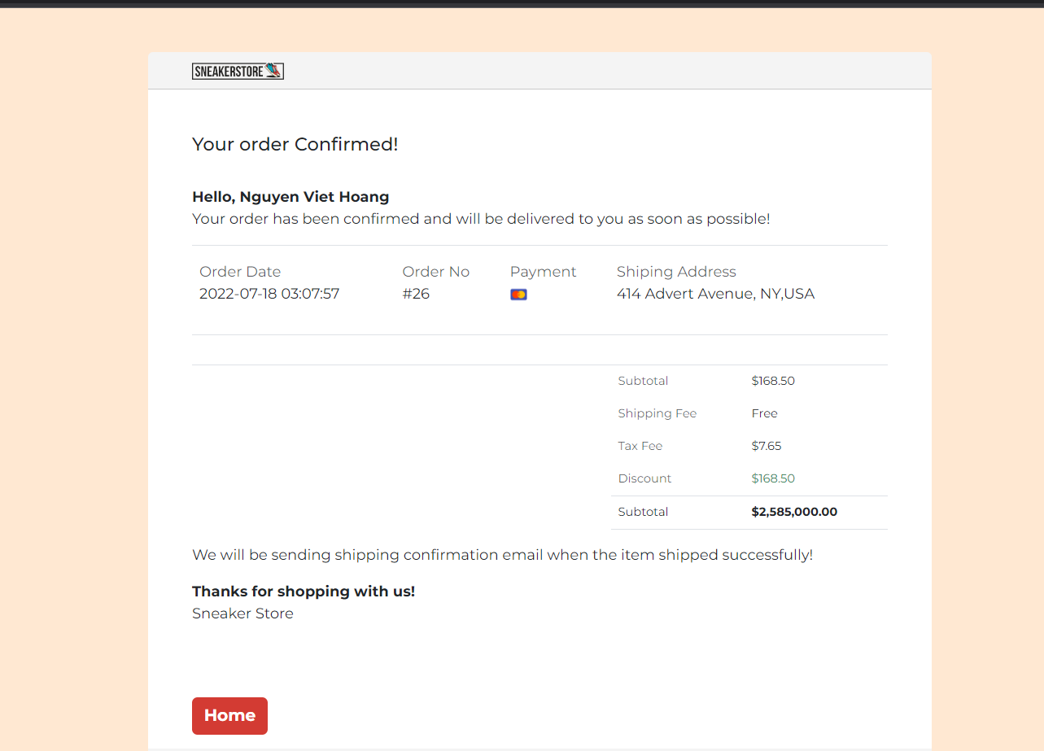
* Function detail :

- Display and list the product and order status of the customer when the order is successful or failed

## 4. Admin

*a. Users List*

Function trigger : HomeController/ListUserController

Function description: Admin

Screen layout :

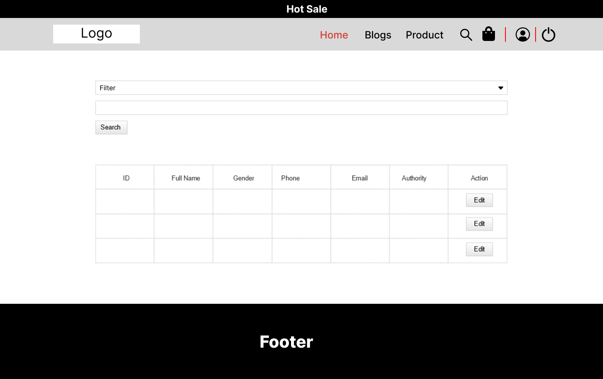

Function detail :

* Show the paginated list of registered users (include users' id, full name, gender, email, mobile, role, status):
* Allow the admin to seach users by full name, email, mobile
* The list is sortable by id, fullname, gender, email, mobile, role, status
* From each user, the admin can choose to view or edit it
* The page also have the button/link that allows the admin to add new user

*b. User detail*

Function trigger : HomeController/ListUserController/ProfileUserController

Function description: Admin

Screen layout :



Function detail :

* Show detailed user information (avatar, full name, gender, email, mobile, role, address, status), from that allow the user to add new, view or edit user information
* The admin can only edit/update the role and status of the user

c. Admin Messenger

Function trigger: Homepage/Admin/Chat

Function description: Admin

Screen layout:

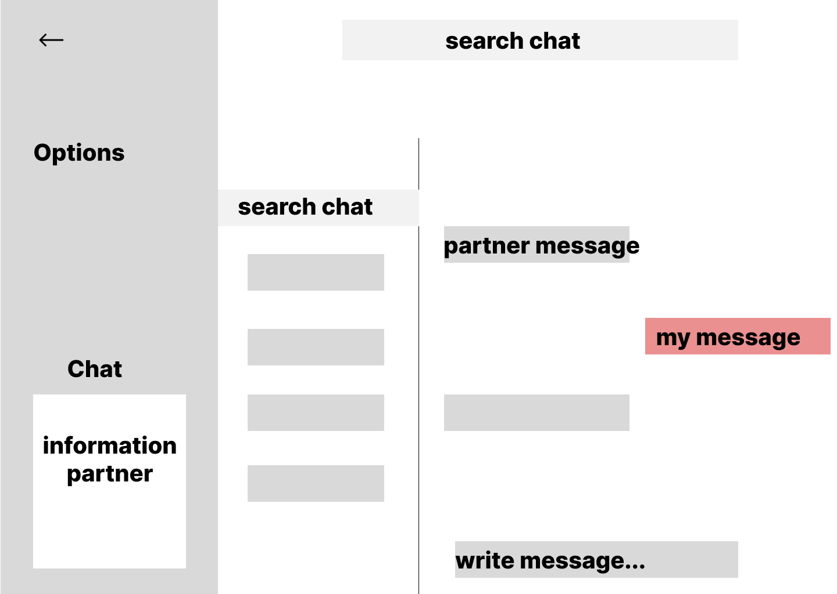

* Function detail:

Show content messages all User,Customer with Admin

Admin can send message to Users

User must be logged in to be able to send messages

d. Post Manager

Function trigger: ShopOnline/Admin/ PostController

Function description: Admin

Screen layout:

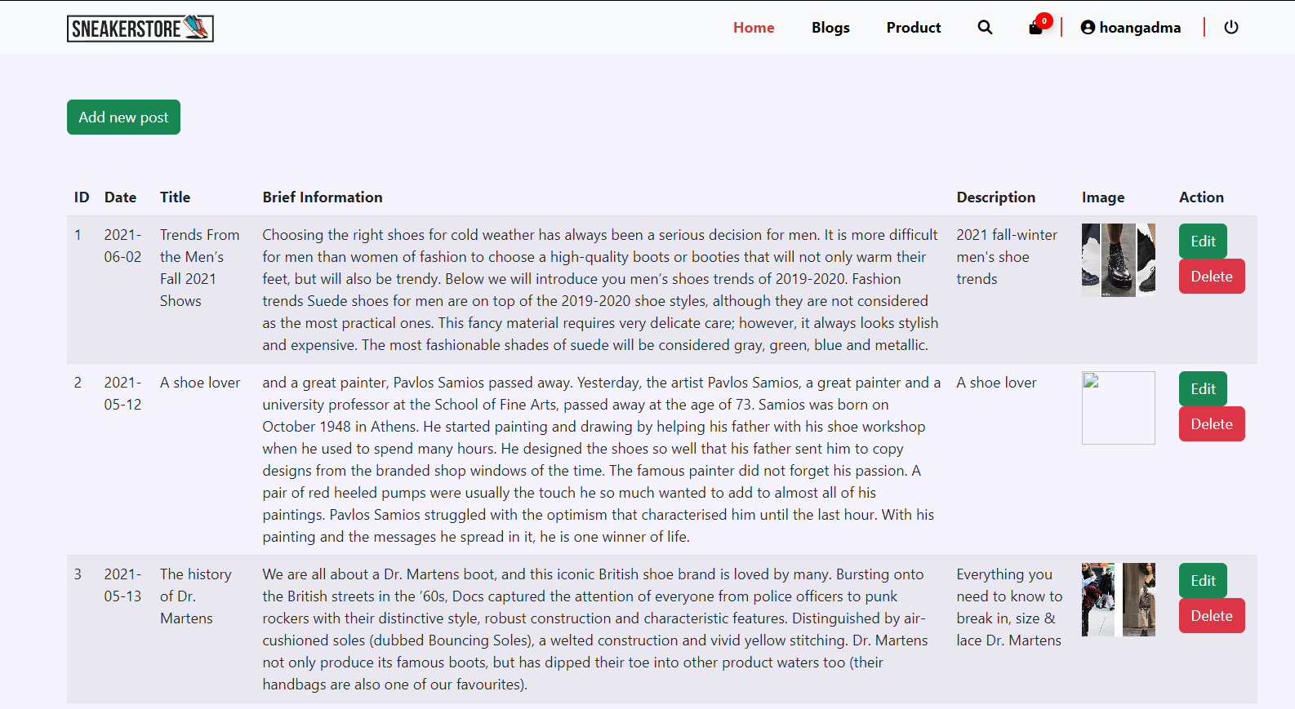

Function detail:

* Display and edit post information in Post Detail

e.Suppliers List

Function trigger: Homepage/admin/suppliers

Function description: User,admin

Screen layout:

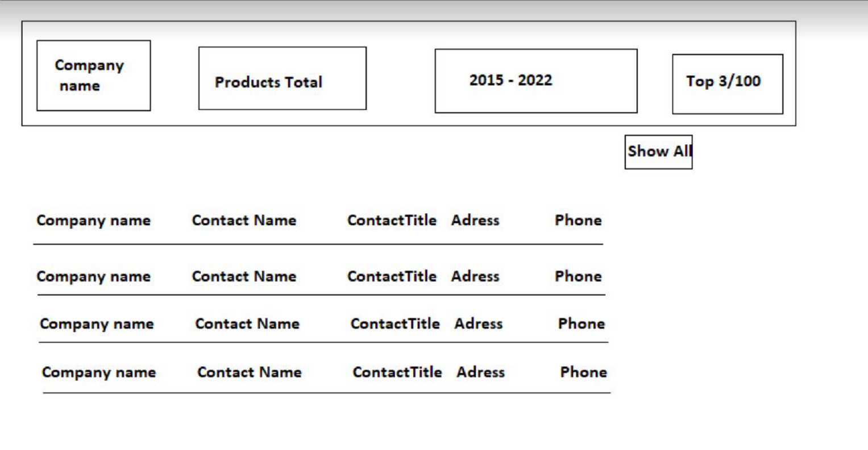

Function detail:

* Display product information of product suppliers for the shop

g.Suppliers List2

Function trigger: Homepage/admin/suppliers

Function description: User,admin

Screen layout:

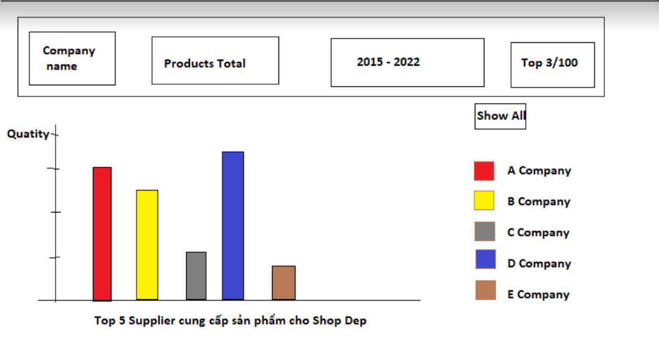

Function detail:

* Display information about the top 5 suppliers for the shop, corresponding to the screen chart

## 5. Customer

*a. My Orders*

Function trigger: Homepage/My order

Function description: User, Admin

Screen layout:

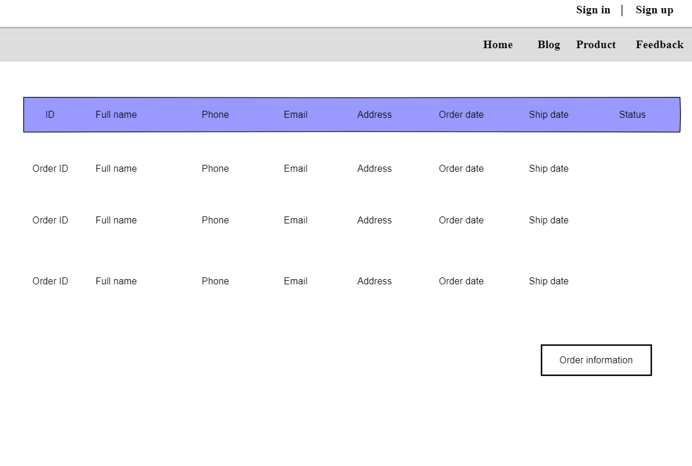

Function detail:

- Show the paginated list of orders with the slider containing search box, product category,..

- Each order will contain order date, product information, cost and status

- Click the link at order id to go to Order Information page

c.Customer Messenger

Function trigger: Homepage

Function description: User, Customer

Screen layout:

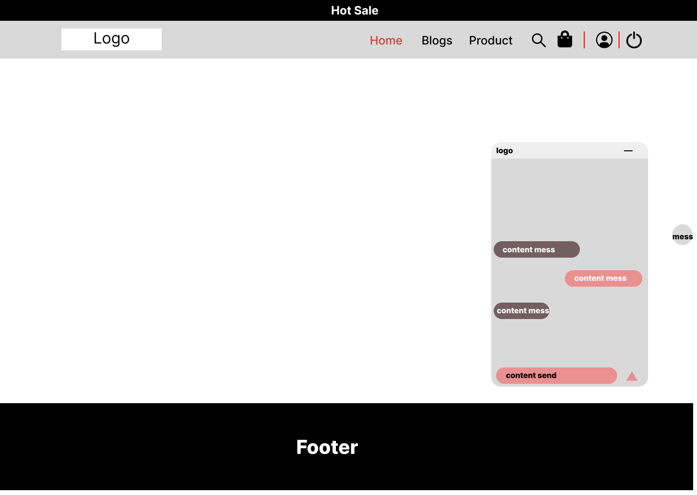

Function detail:

-Show content messenger User,Customer with Admin

- User can send message to Admin

- User must be logged in to be able to send messages

d. Customer Favourite

Screen layout:

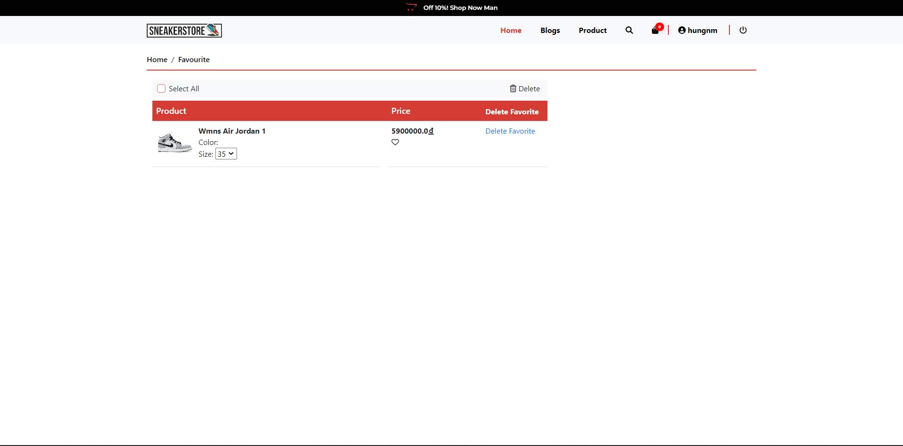

Function detail:

-Show product that user add to favourite

6. BlogAdmin

a. Blog List

Screen layout:

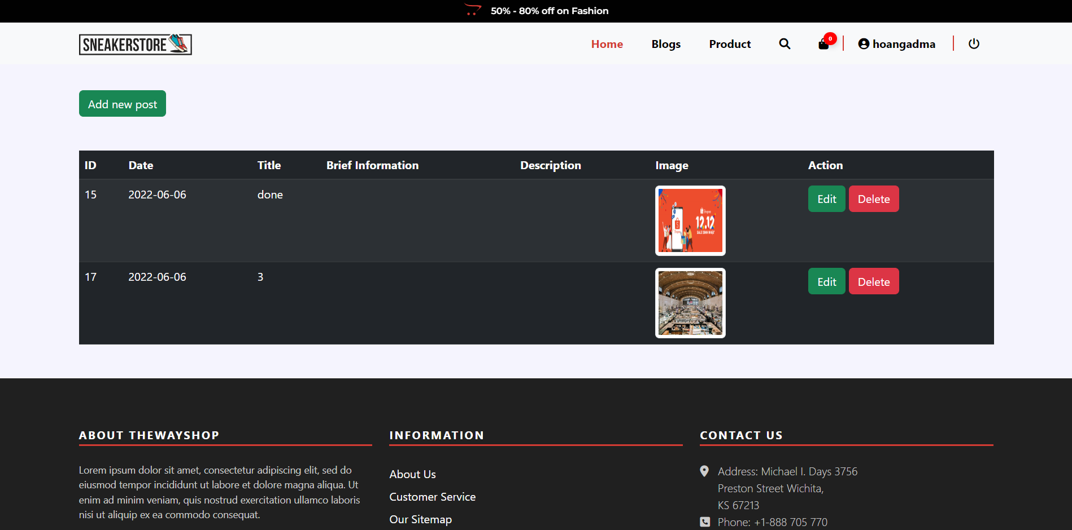

Function detail:

-Show blog list

b. Blog Add

Screen layout:

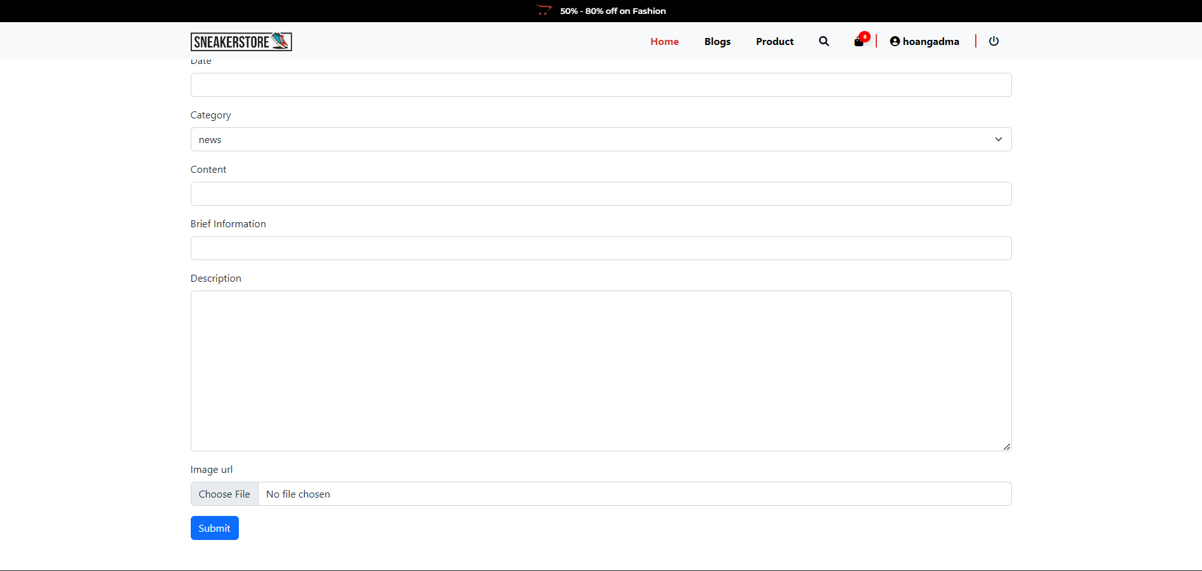

Function detail:

-Show page that admin can add blog.

c. Blog Update

Screen layout:

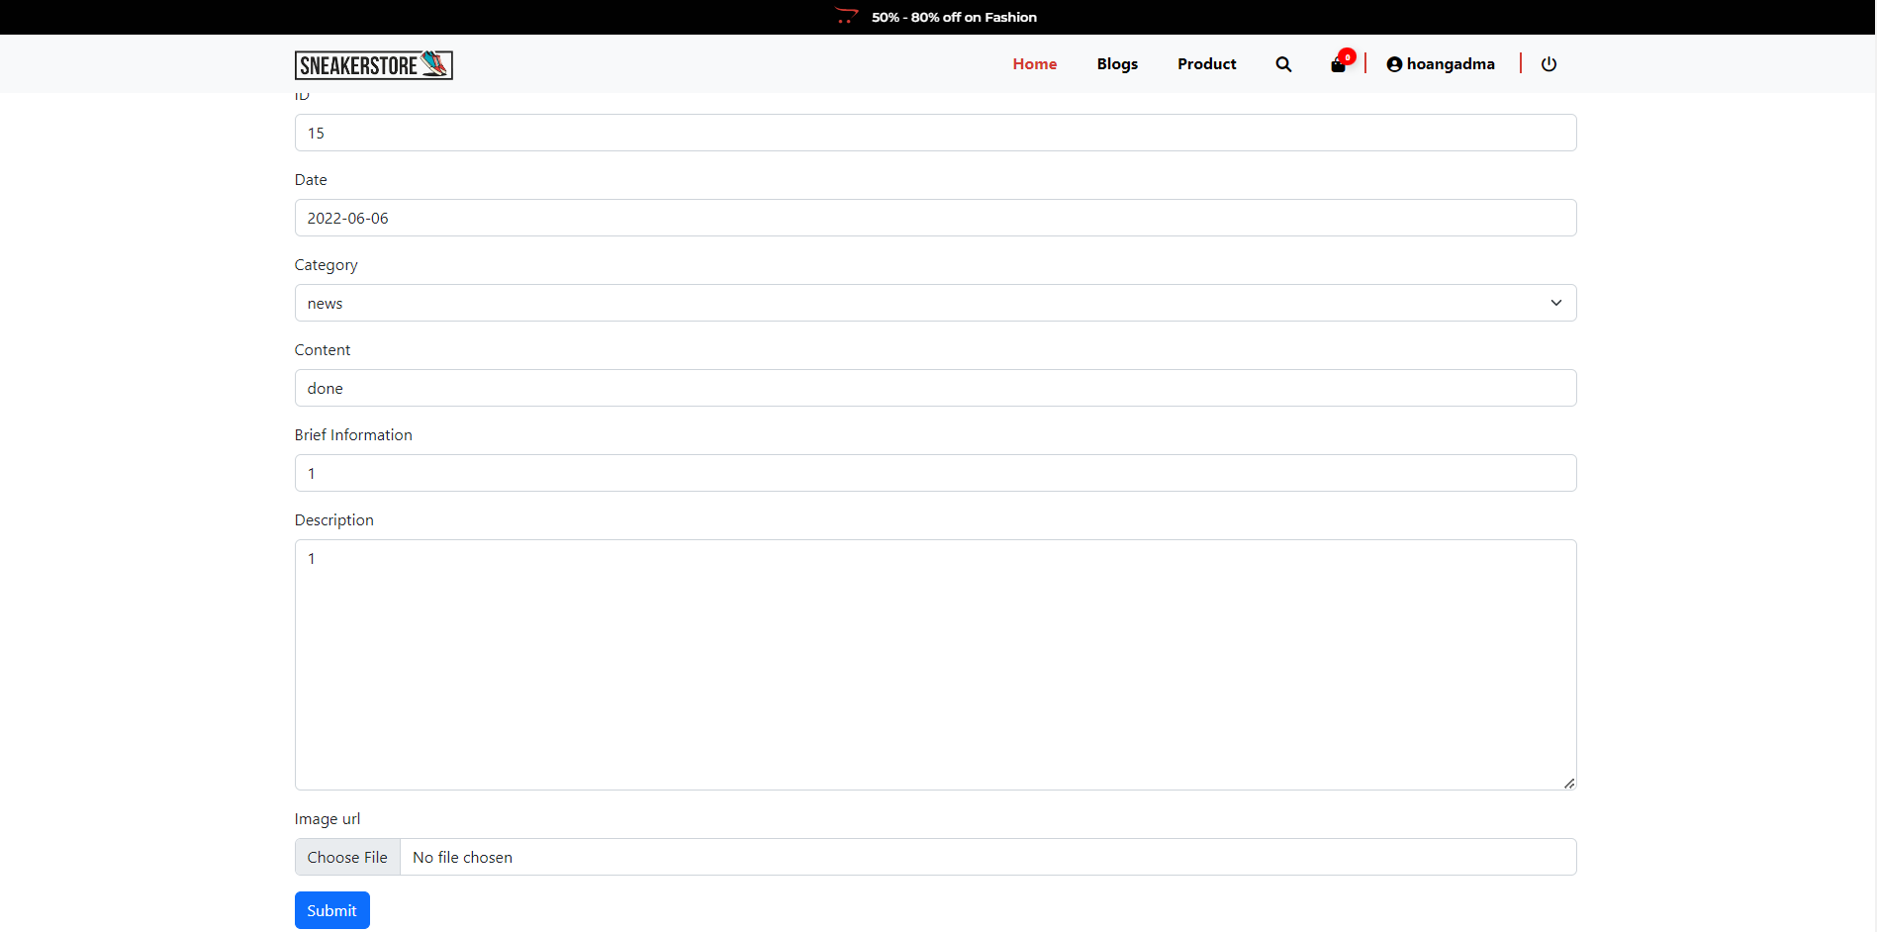

Function detail:

-Show page admin can edit blog.